 

Advanced database and technology

ADVANCED DATABASE PROJECT-II

October 30, 2025

UWANYIRIGIRA CLAUDINE

Reg No: 224020280

Q1. Create the schema with PK/FK and domain constraints.

ANSWER:This schema models the full beverage distribution life cycle, enforcing data integrity through **primary keys**, **foreign keys**, and **domain constraints**.

Key Concepts

**\* Primary Keys (PK):** Uniquely identify each record in a table

**\* Foreign Keys (FK):** Link related records across tables to maintain referential integrity.

**\* Domain Constraints:** Restrict values in columns (e.g., data types, allowed ranges, formats, status values).

1.PRODUCT TABLE (ProductID, ProductName, Category, UnitPrice, VolumeML, Status)

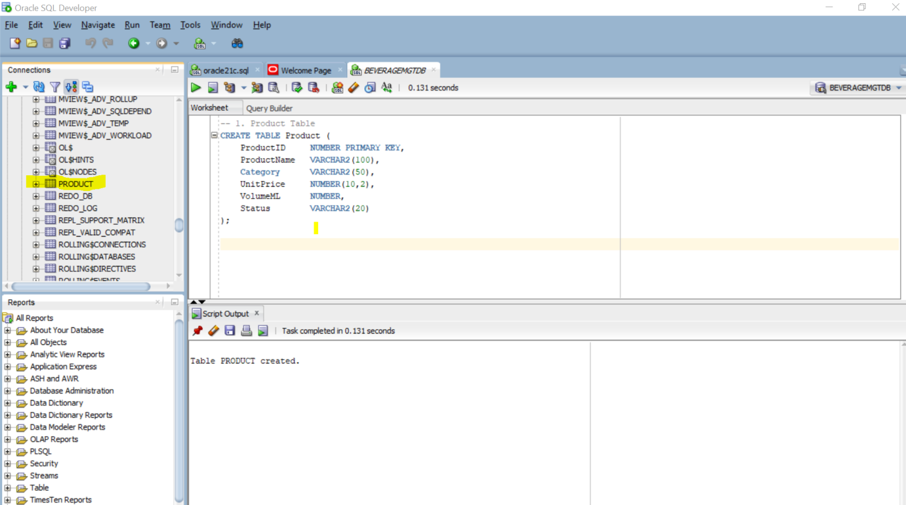

This is for creating product table in database of beverage factory.

1. BATCH TABLE(BatchID, ProductID, ProductionDate, Quantity, ExpiryDate)

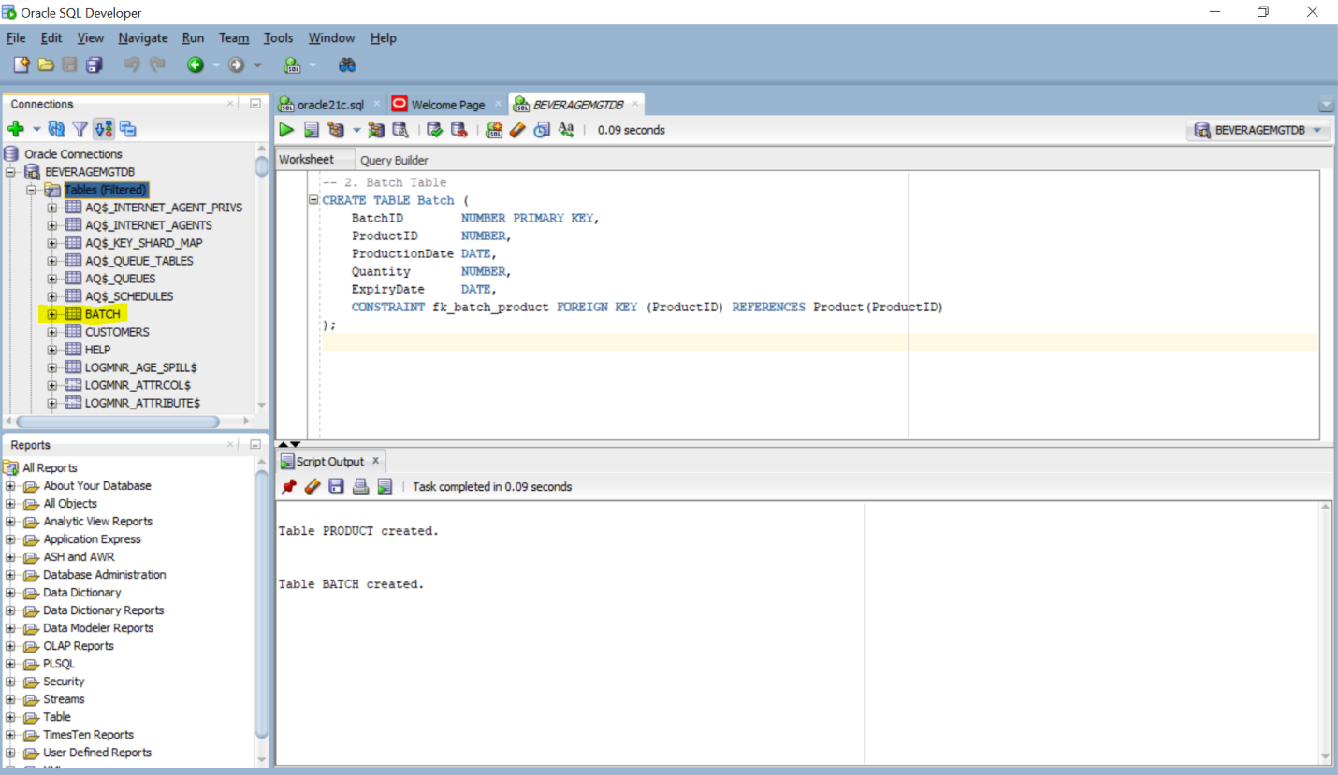

This is for creating Batch table in database of beverage factory.

1. DISTRIBUTOR TABLE (DistributorID, Name, Contact, Region, LicenseNo)

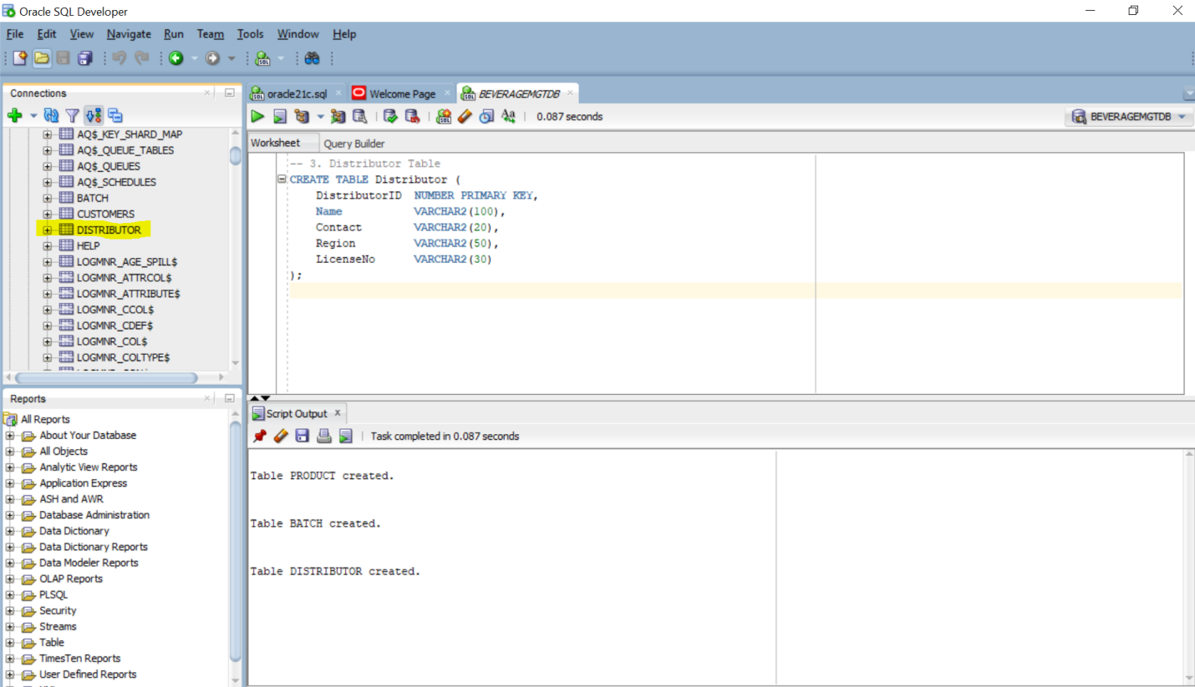

This is for creating distributor table in database of beverage factory.

1. DELIVERY TABLE (DeliveryID, BatchID, DistributorID, DateDelivered, Quantity)

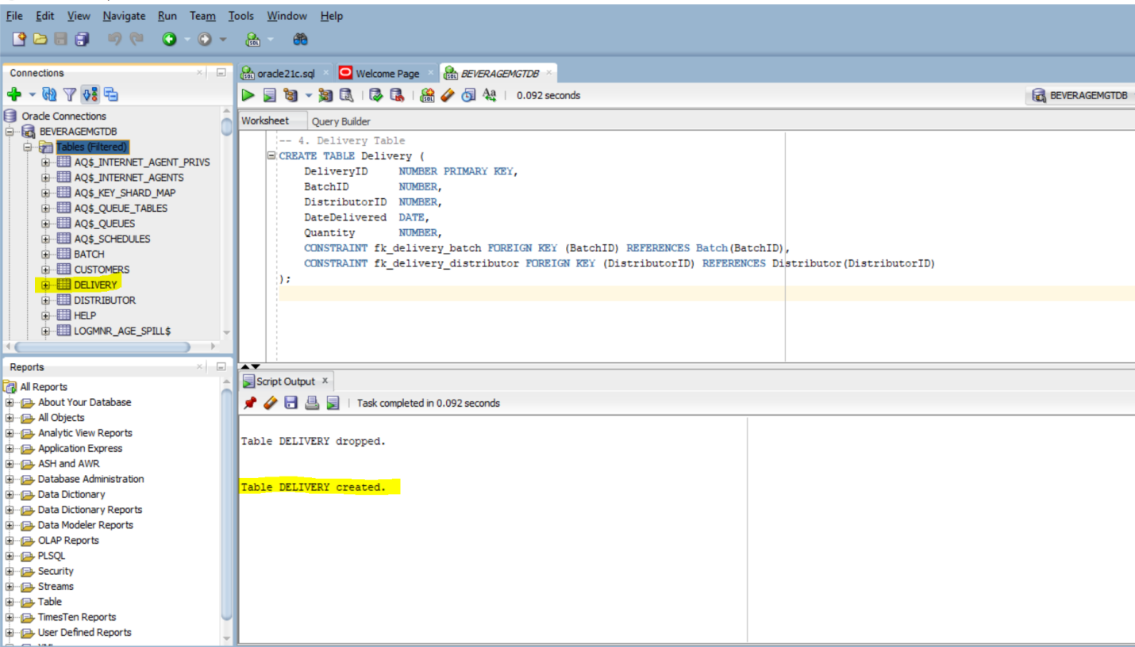

This is for creating delivery table in database of beverage factory.

1. INVOICE TABLE (InvoiceID, DeliveryID, TotalAmount, DueDate, Status)

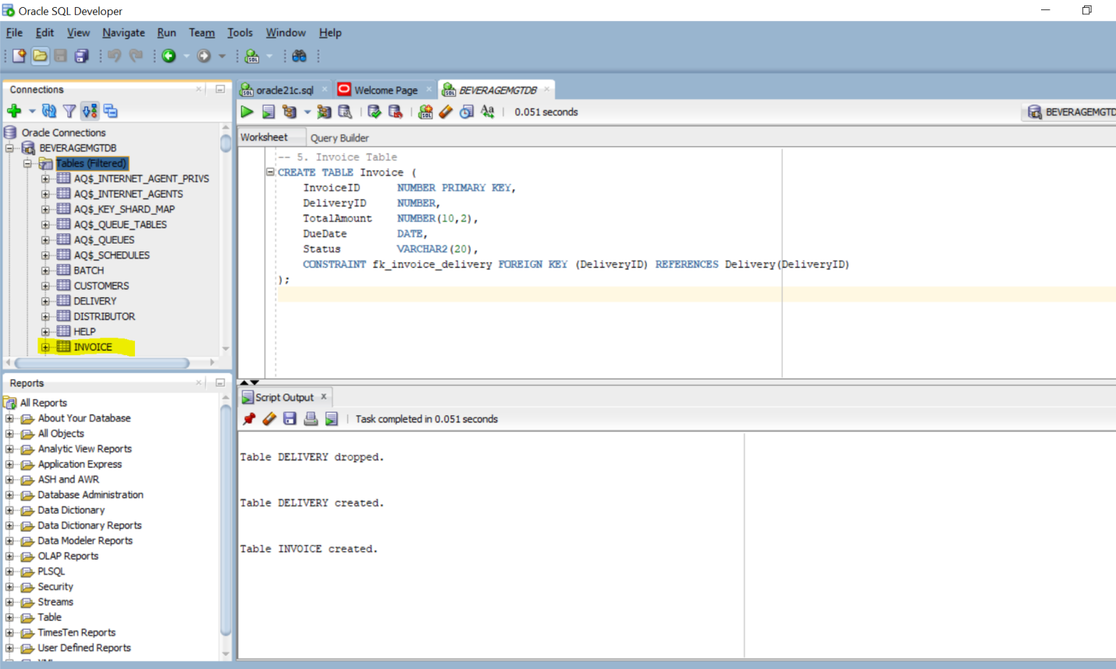

This is for creating invoice table in database of beverage factory.

1. PAYMENT TABLE (PaymentID, InvoiceID, Amount, PaymentDate, Method)

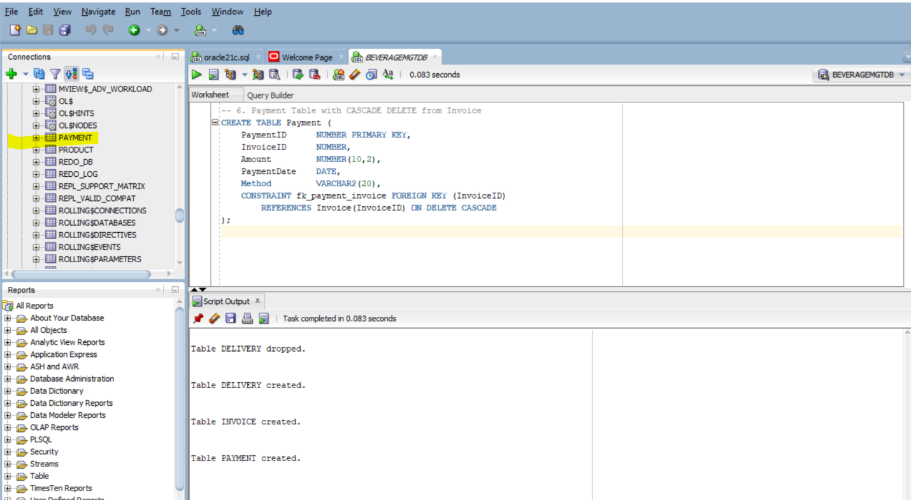

This is for creating payment table in database of beverage factory.

Q2. Apply CASCADE DELETE between Invoice → Payment.

**CASCADE DELETE:**  is a referential integrity rule that automatically removes dependent records when a parent record is deleted. In this case:

If an **Invoice** is deleted, all related **Payments** linked to that invoice are **automatically deleted**.This prevents orphaned payments and keeps the database clean.

Why Use It Here?Because In the Beverage Distribution System:

* Each **Payment** is tied to one **Invoice**.

* If an invoice is canceled or removed (e.g., due to delivery issues or refunds), its payments should also be removed to avoid confusion or invalid financial records.

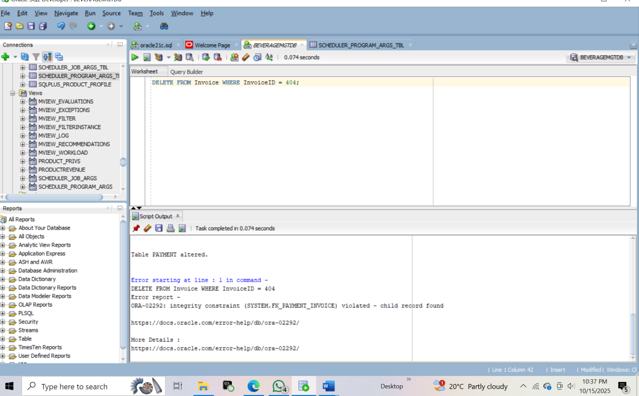

Q3.Insert 5 products, 3 distributors, and 10 deliveries:This data set adds five beverage products, three licensed distributors across Rwanda, and ten delivery records showing how batches move from factory to market.

* INSERT 5 PRODUCTS

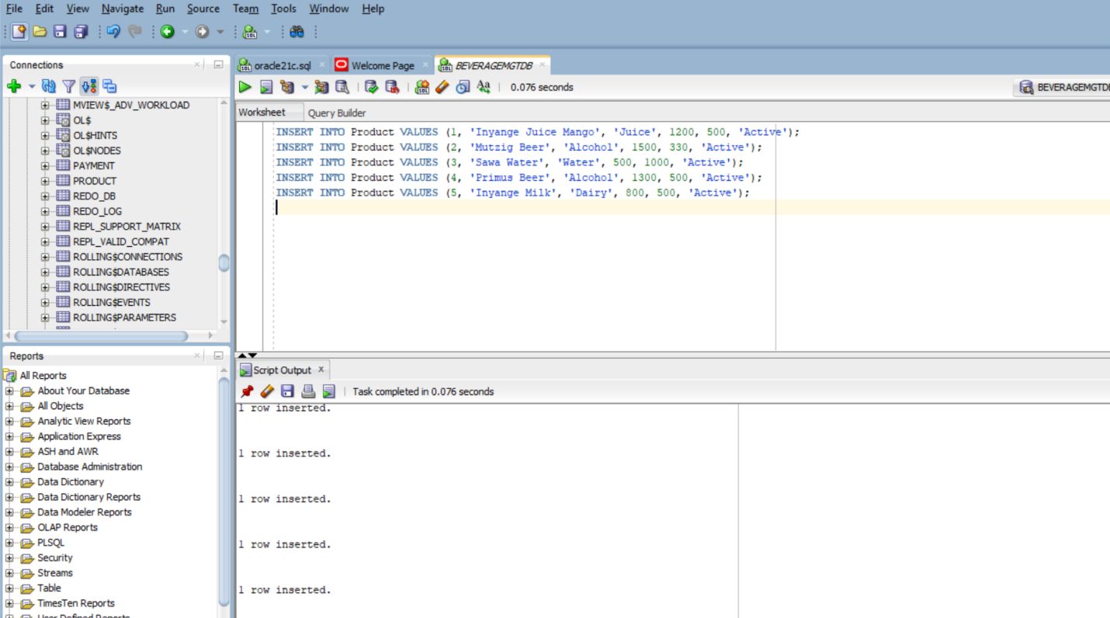

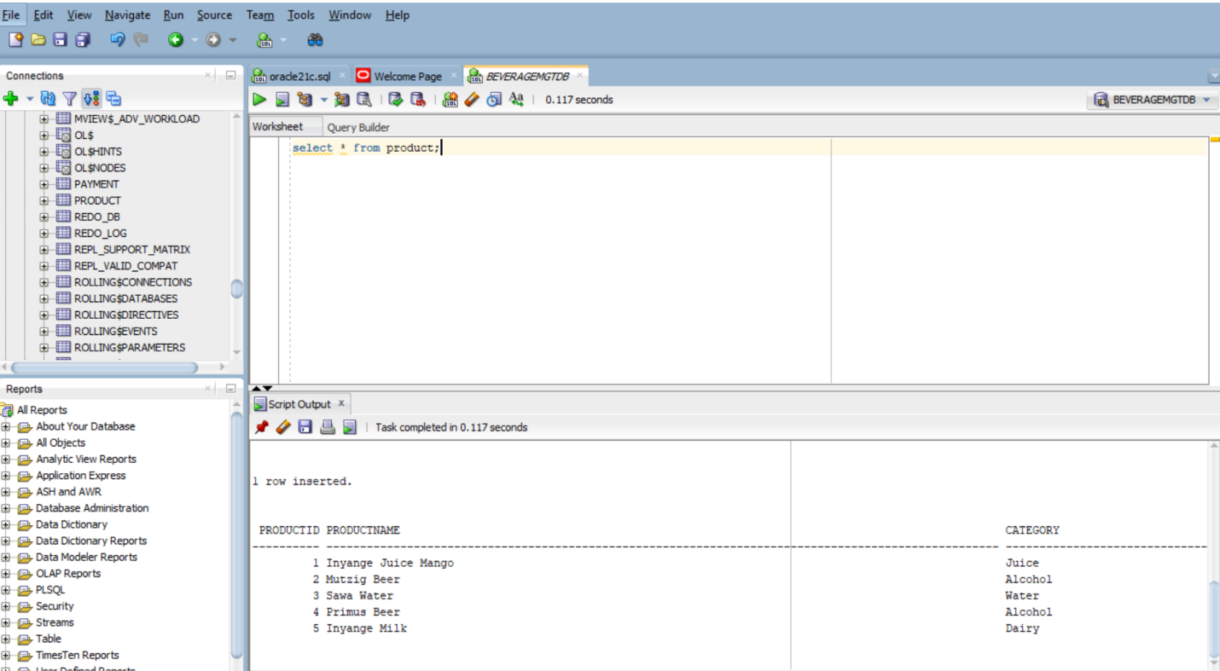

* INSERT 3 DISTRIBUTORS

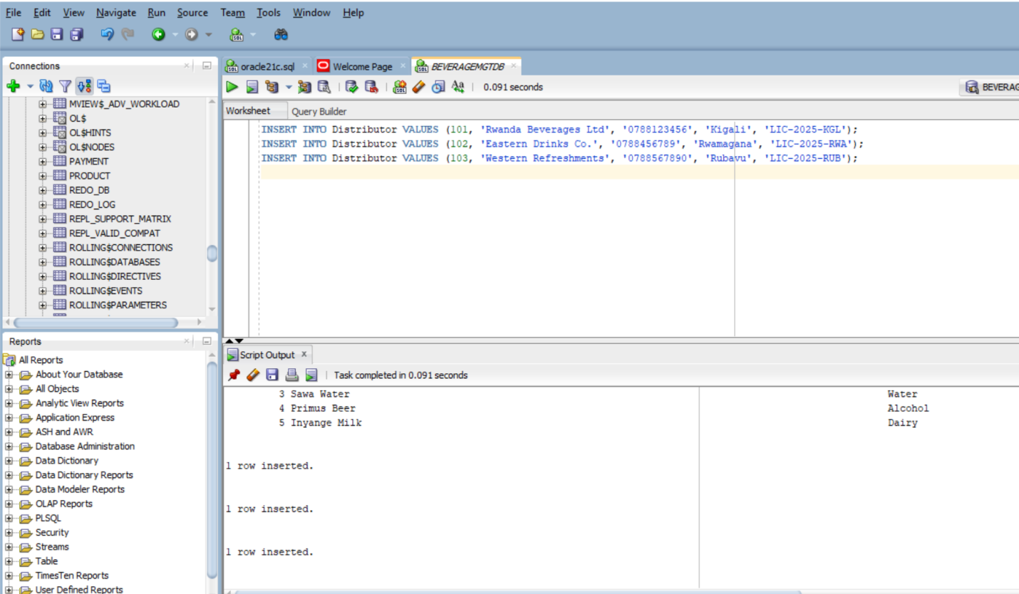

* INSERT 10 DELIVERY

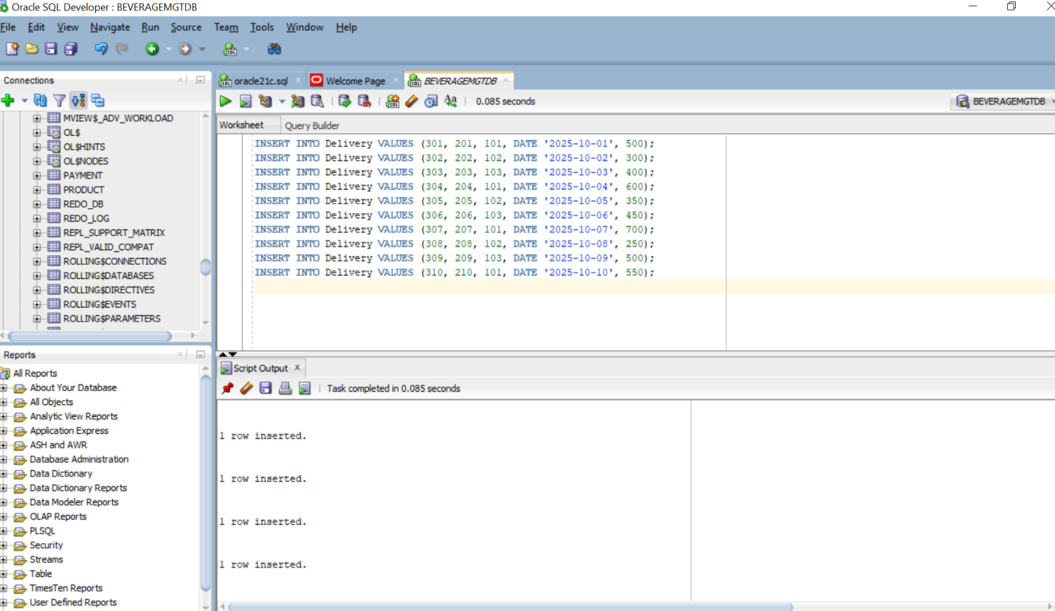

Q4.Retrieve total sales per region: This shows how much each region earned from beverage sales by adding up invoice totals linked to deliveries made to distributors in that region.

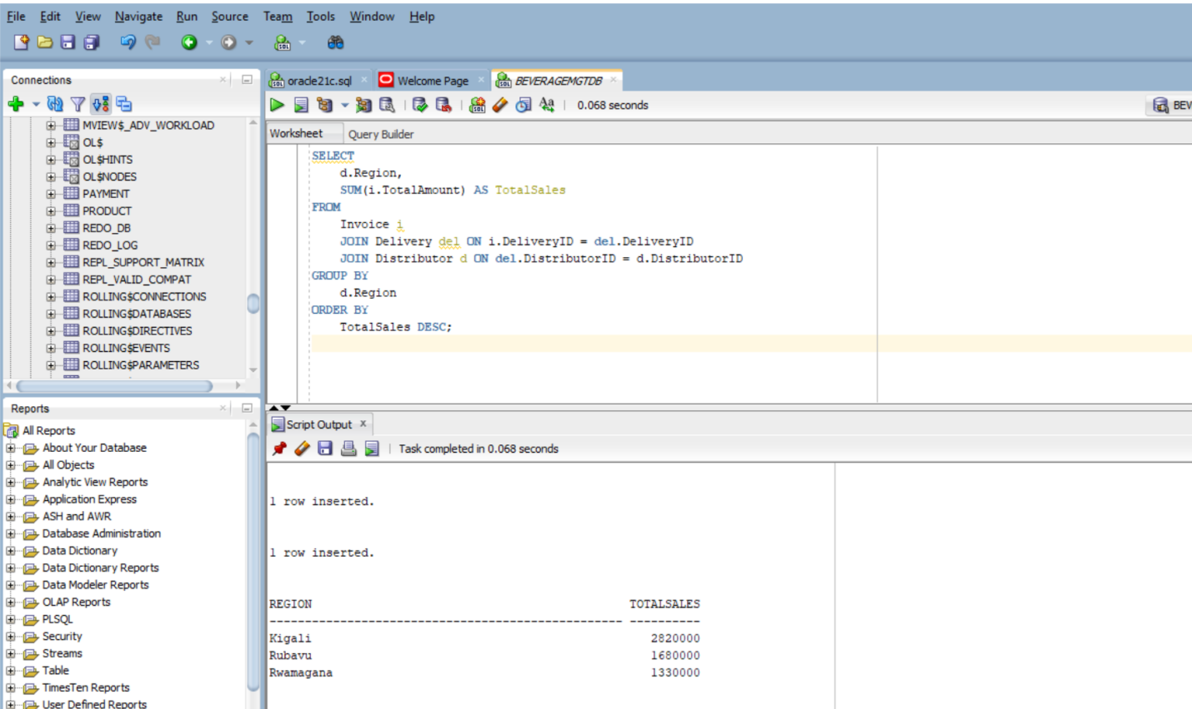

Q5.Update invoice status after payment completion:After a payment is recorded, the invoice status should be updated to "Paid" so the system shows that the distributor has settled the bill.

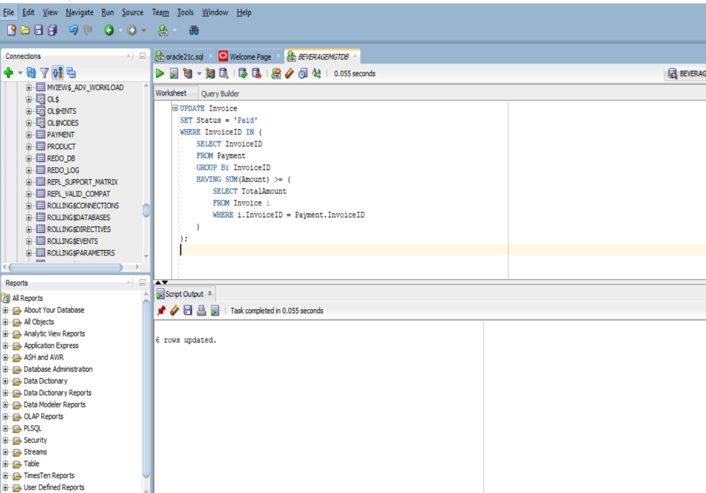

Q6. Identify distributors with overdue invoices:This finds all distributors who have unpaid invoices that are overdue. It helps track who still owes money for delivered products.

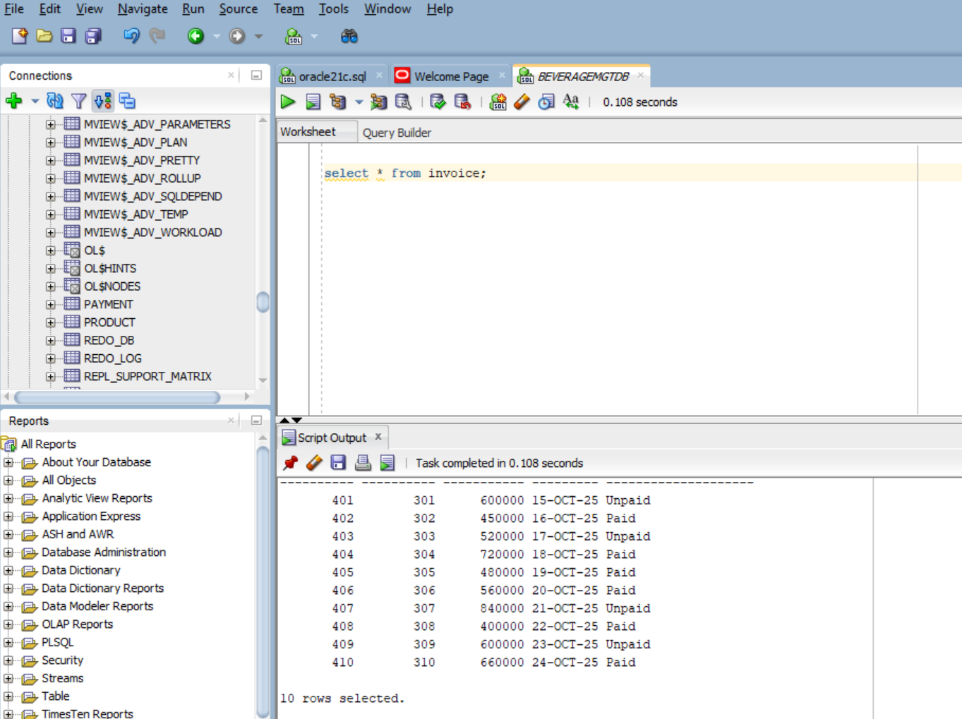

Q7.Create a view showing total revenue per product: This view calculates how much revenue each product has generated by adding up all related invoice totals.

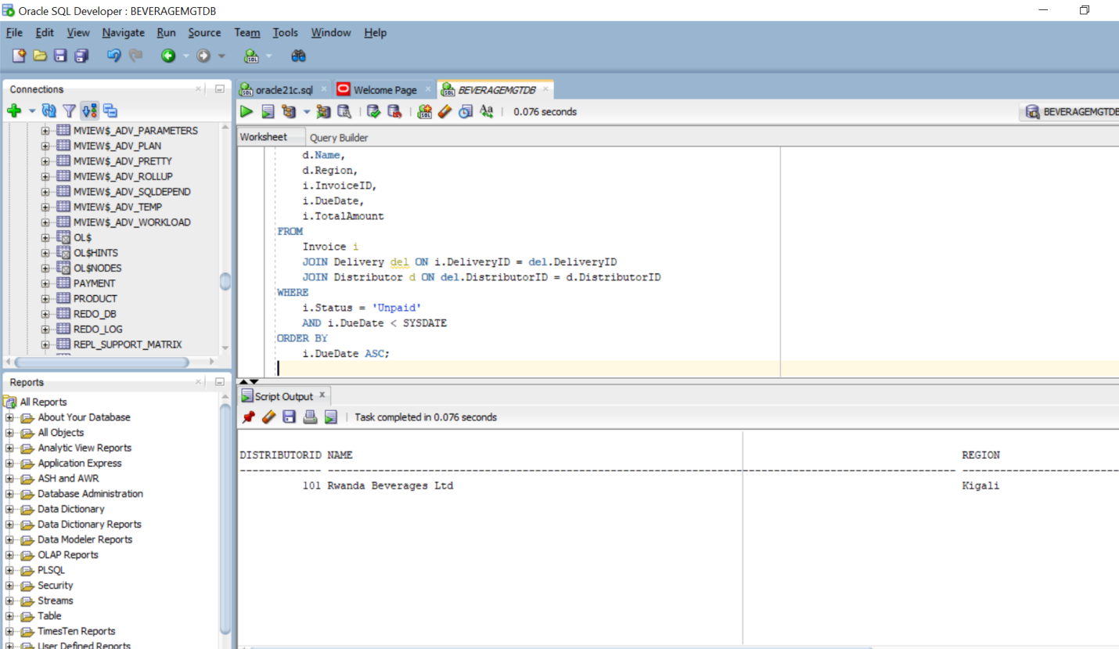

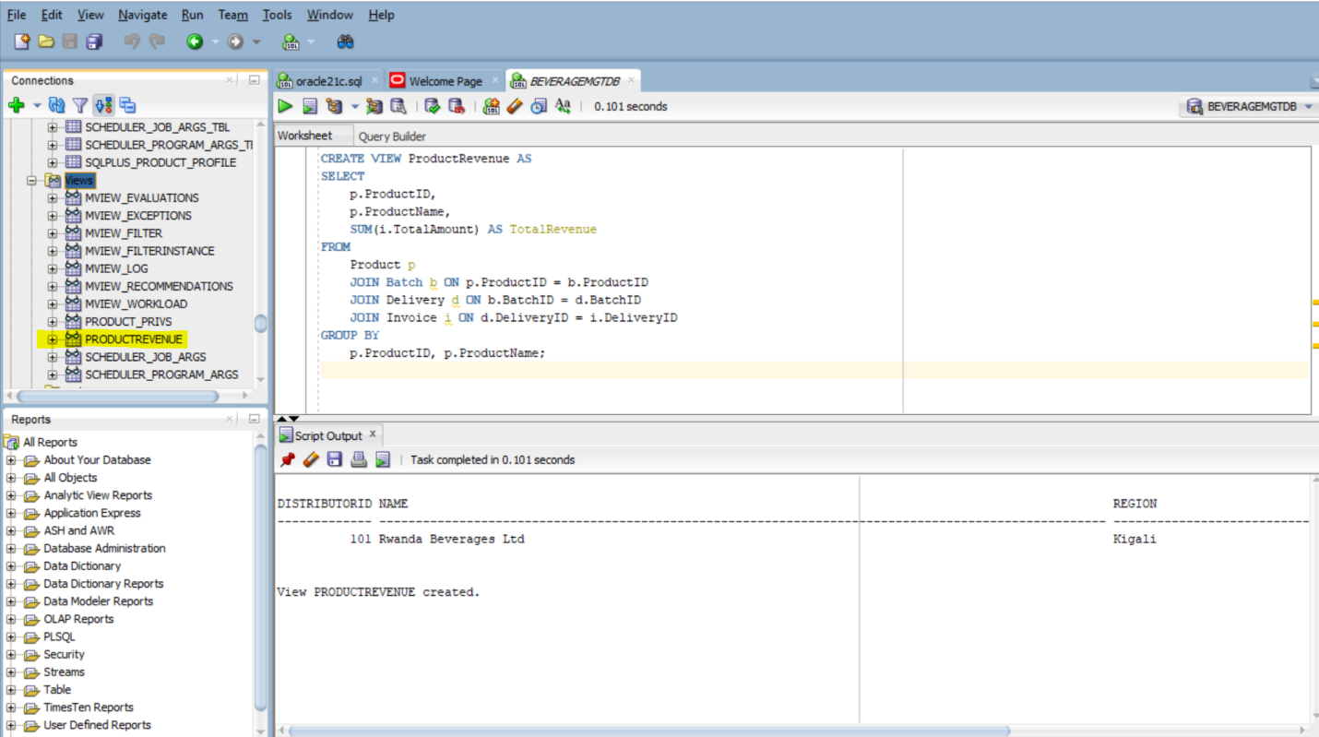

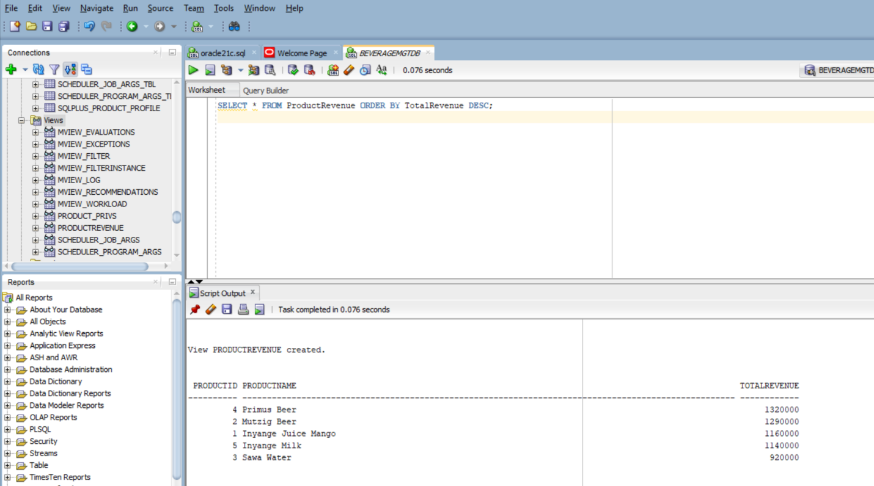

Q8.Implement a trigger marking batches expired after the expiry date: This trigger automatically marks a batch as expired if its expiry date has already passed. It helps keep product status up to date without manual checks.

